**Docker – Container Linking**

Container Linking allows multiple containers to link with each other. It is a better option than exposing ports. Let’s go step by step and learn how it works.

**Step 1**: Download the Jenkins image, if it is not already present, using the Jenkins **pull** command.

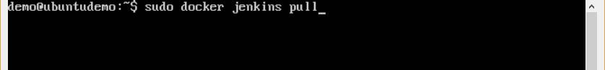

**Step 2**: Once the image is available, run the container, but this time, you can specify aname to the container by using the **–-name** option. This will be our **source container**.

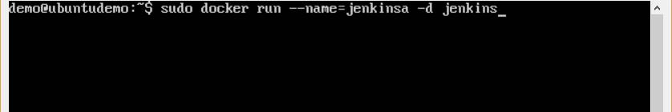

**Step 3**: Next, it is time to launch the destination container, but this time, we will link itwith our source container. For our destination container, we will use the standard Ubuntu image.

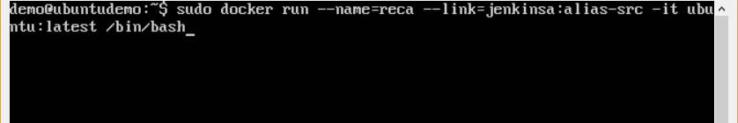

When you do a **docker ps**, you will see both the containers running.

**Step 4**: Now, attach to the receiving container.

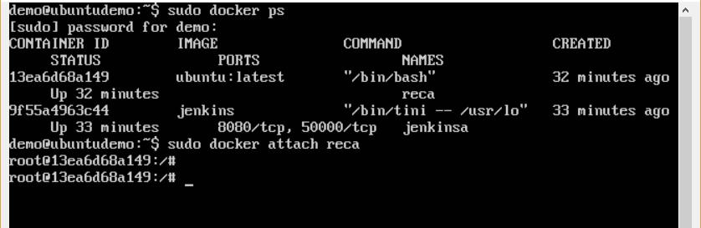

Then run the **env** command. You will notice new variables for linking with the source container.

